- Analisis Deskripsi Karakteristik Responden

Kelas Eksperimen
 |  | Frequency | Percent | Valid Percent | Cumulative Percent
Valid | 42 | 30 | 50,0 | 50,0 | 50,0
Valid | 81 | 30 | 50,0 | 50,0 | 100,0
Valid | Total | 60 | 100,0 | 100,0

Jenis Kelamin
 |  | Frequency | Percent | Valid Percent | Cumulative Percent
Valid | Laki-laki | 13 | 21,7 | 21,7 | 21,7
Valid | Perempuan | 47 | 78,3 | 78,3 | 100,0
Valid | Total | 60 | 100,0 | 100,0

Asal SKPD peserta
 |  | Frequency | Percent | Valid Percent | Cumulative Percent
Valid | Dinas Kesehatan Provinsi DKI J | 15 | 25,0 | 25,0 | 25,0
Valid | Dinas Koperasi, Usaha Kecil da | 1 | 1,7 | 1,7 | 26,7
Valid | Dinas Pemberdayaan, Perlindung | 1 | 1,7 | 1,7 | 28,3
Valid | Dinas Pendidikan Provinsi DKI | 40 | 66,7 | 66,7 | 95,0
Valid | Dinas Perumahan Rakyat dan Kaw | 1 | 1,7 | 1,7 | 96,7
Valid | Dinas Tenaga Kerja dan Transmi | 2 | 3,3 | 3,3 | 100,0
Valid | Total | 60 | 100,0 | 100,0

Kelas Kontrol
 |  | Frequency | Percent | Valid Percent | Cumulative Percent
Valid | 68 | 30 | 50,0 | 50,0 | 50,0
Valid | 84 | 30 | 50,0 | 50,0 | 100,0
Valid | Total | 60 | 100,0 | 100,0

Jenis Kelamin
 |  | Frequency | Percent | Valid Percent | Cumulative Percent
Valid | Laki-laki | 16 | 26,7 | 26,7 | 26,7
Valid | Perempuan | 44 | 73,3 | 73,3 | 100,0
Valid | Total | 60 | 100,0 | 100,0

Asal SKPD peserta
 |  | Frequency | Percent | Valid Percent | Cumulative Percent
Valid | Badan Pelayanan Pengadaan Bara | 2 | 3,3 | 3,3 | 3,3
Valid | Badan Pengelola Aset Daerah Pr | 2 | 3,3 | 3,3 | 6,7
Valid | Badan Pengembangan Sumber Daya | 1 | 1,7 | 1,7 | 8,3
Valid | Badan Perencanaan Pembangunan | 2 | 3,3 | 3,3 | 11,7
Valid | Dinas Cipta Karya, Tata Ruang | 1 | 1,7 | 1,7 | 13,3
Valid | Dinas Kesehatan Provinsi DKI J | 5 | 8,3 | 8,3 | 21,7
Valid | Dinas Lingkungan Hidup Provins | 2 | 3,3 | 3,3 | 25,0
Valid | Dinas Pemberdayaan Perlindunga | 1 | 1,7 | 1,7 | 26,7
Valid | Dinas Pendidikan Provinsi DKI | 42 | 70,0 | 70,0 | 96,7
Valid | Dinas Perumahan Rakyat dan Kaw | 1 | 1,7 | 1,7 | 98,3
Valid | Dins Kesehatan Provinsi DKI Ja | 1 | 1,7 | 1,7 | 100,0
Valid | Total | 60 | 100,0 | 100,0

- Analisis Deskripsi Hasil Penelitian

Descriptives
Descriptive Statistics
 | N | Minimum | Maximum | Mean | Std. Deviation
Pre Test Eksperimen | 60 | 16 | 64 | 44,60 | 12,052
Post Test Eksperimen | 60 | 52 | 96 | 76,93 | 11,606
Pre Test Kontrol | 60 | 12 | 60 | 40,60 | 11,985
Post Test Kontrol | 60 | 40 | 88 | 68,00 | 11,852
Kuesioner | 60 | 44 | 92 | 72,27 | 12,121
Valid N (listwise) | 60

Frequencies
Statistics
 |  | Pre Test Eksperimen | Post Test Eksperimen | Pre Test Kontrol | Post Test Kontrol | Kuesioner
N | Valid | 60 | 60 | 60 | 60 | 60
N | Missing | 60 | 60 | 60 | 60 | 60
Mean |  | 44,60 | 76,93 | 40,60 | 68,00 | 72,27
Median |  | 44,00 | 76,00 | 40,00 | 68,00 | 72,00
Mode |  | 44 | 76 | 40 | 68 | 72
Std. Deviation |  | 12,052 | 11,606 | 11,985 | 11,852 | 12,121
Variance |  | 145,261 | 134,707 | 143,634 | 140,475 | 146,911
Minimum |  | 16 | 52 | 12 | 40 | 44
Maximum |  | 64 | 96 | 60 | 88 | 92
Sum |  | 2676 | 4616 | 2436 | 4080 | 4336

Descriptives
 | Kelas |  |  | Statistic | Std. Error
Hasil Belajar Etika Publik | Pre-Test Eksperimen (Role Playing) | Mean |  | 44,60 | 1,547
Hasil Belajar Etika Publik | Pre-Test Eksperimen (Role Playing) | 95% Confidence Interval for Mean | Lower Bound | 41,50
Hasil Belajar Etika Publik | Pre-Test Eksperimen (Role Playing) | 95% Confidence Interval for Mean | Upper Bound | 47,70
Hasil Belajar Etika Publik | Pre-Test Eksperimen (Role Playing) | 5% Trimmed Mean |  | 44,89
Hasil Belajar Etika Publik | Pre-Test Eksperimen (Role Playing) | Median |  | 44,00
Hasil Belajar Etika Publik | Pre-Test Eksperimen (Role Playing) | Variance |  | 143,634
Hasil Belajar Etika Publik | Pre-Test Eksperimen (Role Playing) | Std. Deviation |  | 11,985
Hasil Belajar Etika Publik | Pre-Test Eksperimen (Role Playing) | Minimum |  | 16
Hasil Belajar Etika Publik | Pre-Test Eksperimen (Role Playing) | Maximum |  | 64
Hasil Belajar Etika Publik | Pre-Test Eksperimen (Role Playing) | Range |  | 48
Hasil Belajar Etika Publik | Pre-Test Eksperimen (Role Playing) | Interquartile Range |  | 16
Hasil Belajar Etika Publik | Pre-Test Eksperimen (Role Playing) | Skewness |  | -,165 | ,309
Hasil Belajar Etika Publik | Pre-Test Eksperimen (Role Playing) | Kurtosis |  | -,630 | ,608
Hasil Belajar Etika Publik | Post-Test Eksperimen (Role Playing) | Mean |  | 76,93 | 1,498
Hasil Belajar Etika Publik | Post-Test Eksperimen (Role Playing) | 95% Confidence Interval for Mean | Lower Bound | 73,94
Hasil Belajar Etika Publik | Post-Test Eksperimen (Role Playing) | 95% Confidence Interval for Mean | Upper Bound | 79,93
Hasil Belajar Etika Publik | Post-Test Eksperimen (Role Playing) | 5% Trimmed Mean |  | 77,11
Hasil Belajar Etika Publik | Post-Test Eksperimen (Role Playing) | Median |  | 76,00
Hasil Belajar Etika Publik | Post-Test Eksperimen (Role Playing) | Variance |  | 134,707
Hasil Belajar Etika Publik | Post-Test Eksperimen (Role Playing) | Std. Deviation |  | 11,606
Hasil Belajar Etika Publik | Post-Test Eksperimen (Role Playing) | Minimum |  | 52
Hasil Belajar Etika Publik | Post-Test Eksperimen (Role Playing) | Maximum |  | 96
Hasil Belajar Etika Publik | Post-Test Eksperimen (Role Playing) | Range |  | 44
Hasil Belajar Etika Publik | Post-Test Eksperimen (Role Playing) | Interquartile Range |  | 16
Hasil Belajar Etika Publik | Post-Test Eksperimen (Role Playing) | Skewness |  | -,085 | ,309
Hasil Belajar Etika Publik | Post-Test Eksperimen (Role Playing) | Kurtosis |  | -,810 | ,608
Hasil Belajar Etika Publik | Pre-Test Kontrol | Mean |  | 40,60 | 1,547
Hasil Belajar Etika Publik | Pre-Test Kontrol | 95% Confidence Interval for Mean | Lower Bound | 37,50
Hasil Belajar Etika Publik | Pre-Test Kontrol | 95% Confidence Interval for Mean | Upper Bound | 43,70
Hasil Belajar Etika Publik | Pre-Test Kontrol | 5% Trimmed Mean |  | 40,89
Hasil Belajar Etika Publik | Pre-Test Kontrol | Median |  | 40,00
Hasil Belajar Etika Publik | Pre-Test Kontrol | Variance |  | 143,634
Hasil Belajar Etika Publik | Pre-Test Kontrol | Std. Deviation |  | 11,985
Hasil Belajar Etika Publik | Pre-Test Kontrol | Minimum |  | 12
Hasil Belajar Etika Publik | Pre-Test Kontrol | Maximum |  | 60
Hasil Belajar Etika Publik | Pre-Test Kontrol | Range |  | 48
Hasil Belajar Etika Publik | Pre-Test Kontrol | Interquartile Range |  | 16
Hasil Belajar Etika Publik | Pre-Test Kontrol | Skewness |  | -,165 | ,309
Hasil Belajar Etika Publik | Pre-Test Kontrol | Kurtosis |  | -,630 | ,608
Hasil Belajar Etika Publik | Post-Test Kontrol | Mean |  | 68,00 | 1,530
Hasil Belajar Etika Publik | Post-Test Kontrol | 95% Confidence Interval for Mean | Lower Bound | 64,94
Hasil Belajar Etika Publik | Post-Test Kontrol | 95% Confidence Interval for Mean | Upper Bound | 71,06
Hasil Belajar Etika Publik | Post-Test Kontrol | 5% Trimmed Mean |  | 68,30
Hasil Belajar Etika Publik | Post-Test Kontrol | Median |  | 68,00
Hasil Belajar Etika Publik | Post-Test Kontrol | Variance |  | 140,475
Hasil Belajar Etika Publik | Post-Test Kontrol | Std. Deviation |  | 11,852
Hasil Belajar Etika Publik | Post-Test Kontrol | Minimum |  | 40
Hasil Belajar Etika Publik | Post-Test Kontrol | Maximum |  | 88
Hasil Belajar Etika Publik | Post-Test Kontrol | Range |  | 48
Hasil Belajar Etika Publik | Post-Test Kontrol | Interquartile Range |  | 16
Hasil Belajar Etika Publik | Post-Test Kontrol | Skewness |  | -,186 | ,309
Hasil Belajar Etika Publik | Post-Test Kontrol | Kurtosis |  | -,421 | ,608

- Hasil Uji Validitas Instrumen

- Validitas Instrumen Kuesioner Metode Role Playing (X)
Butir Pernyataan | r-hitung (Corrected Item-Total Correlation) | r-tabel  (df: n-2) | Kriteria
X1 | 0,549 | 0,361 | Valid
X2 | 0,639 | 0,361 | Valid
X3 | 0,579 | 0,361 | Valid
X4 | 0,671 | 0,361 | Valid
X5 | 0,578 | 0,361 | Valid
X6 | 0,623 | 0,361 | Valid
X7 | 0,659 | 0,361 | Valid
X8 | 0,577 | 0,361 | Valid
X9 | 0,762 | 0,361 | Valid
X10 | 0,701 | 0,361 | Valid
X11 | 0,631 | 0,361 | Valid
X12 | 0,708 | 0,361 | Valid
X13 | 0,671 | 0,361 | Valid
X14 | 0,665 | 0,361 | Valid
X15 | 0,783 | 0,361 | Valid
X16 | 0,726 | 0,361 | Valid
X17 | 0,713 | 0,361 | Valid
X18 | 0,725 | 0,361 | Valid
X19 | 0,728 | 0,361 | Valid
X20 | 0,599 | 0,361 | Valid

- Validitas Instrumen Soal Test Hasil Belajar
Butir Pertanyaan | Nilai r (Corrected Item-Total Correlation) | r-tabel  (df : n-2) | Kriteria
Y1 | 0,913 | 0,361 | Valid
Y2 | 0,864 | 0,361 | Valid
Y3 | 0,721 | 0,361 | Valid
Y4 | 0,721 | 0,361 | Valid
Y5 | 0,814 | 0,361 | Valid
Y6 | 0,553 | 0,361 | Valid
Y7 | 0,756 | 0,361 | Valid
Y8 | 0,418 | 0,361 | Valid
Y9 | 0,797 | 0,361 | Valid
Y10 | 0,797 | 0,361 | Valid
Y11 | 0,513 | 0,361 | Valid
Y12 | 0,582 | 0,361 | Valid
Y13 | 0,553 | 0,361 | Valid
Y14 | 0,513 | 0,361 | Valid
Y15 | 0,721 | 0,361 | Valid
Y16 | 0,721 | 0,361 | Valid
Y17 | 0,450 | 0,361 | Valid
Y18 | 0,481 | 0,361 | Valid
Y19 | 0,513 | 0,361 | Valid
Y20 | 0,758 | 0,361 | Valid
Y21 | 0,553 | 0,361 | Valid
Y22 | 0,495 | 0,361 | Valid
Y23 | 0,913 | 0,361 | Valid
Y24 | 0,721 | 0,361 | Valid
Y25 | 0,582 | 0,361 | Valid
- Hasil Uji Realibilitas Instrumen

Reliability Statistics
Cronbach's Alpha | N of Items
,932 | 20

Item-Total Statistics
 | Scale Mean if Item Deleted | Scale Variance if Item Deleted | Corrected Item-Total Correlation | Cronbach's Alpha if Item Deleted
X1 | 82,67 | 40,368 | ,500 | ,931
X2 | 82,80 | 39,407 | ,592 | ,929
X3 | 82,87 | 39,706 | ,524 | ,931
X4 | 83,03 | 39,137 | ,626 | ,929
X5 | 83,23 | 39,840 | ,526 | ,931
X6 | 83,07 | 39,513 | ,574 | ,930
X7 | 83,00 | 39,172 | ,612 | ,929
X8 | 83,30 | 38,907 | ,508 | ,932
X9 | 83,07 | 38,616 | ,728 | ,927
X10 | 83,23 | 39,702 | ,667 | ,928
X11 | 83,13 | 39,637 | ,585 | ,930
X12 | 83,07 | 38,961 | ,668 | ,928
X13 | 82,97 | 39,068 | ,625 | ,929
X14 | 83,20 | 39,131 | ,619 | ,929
X15 | 83,07 | 38,478 | ,752 | ,926
X16 | 83,30 | 38,700 | ,686 | ,928
X17 | 83,03 | 38,861 | ,673 | ,928
X18 | 83,27 | 39,099 | ,690 | ,928
X19 | 83,07 | 38,271 | ,684 | ,928
X20 | 82,87 | 39,568 | ,547 | ,930

Reliability Statistics
Cronbach's Alpha | N of Items
,947 | 25

Item-Total Statistics
 | Scale Mean if Item Deleted | Scale Variance if Item Deleted | Corrected Item-Total Correlation | Cronbach's Alpha if Item Deleted
Y1 | 20,10 | 34,024 | ,899 | ,941
Y2 | 20,00 | 34,897 | ,847 | ,942
Y3 | 19,93 | 36,133 | ,692 | ,944
Y4 | 19,93 | 36,133 | ,692 | ,944
Y5 | 20,07 | 34,754 | ,787 | ,943
Y6 | 19,97 | 36,654 | ,508 | ,947
Y7 | 19,97 | 35,689 | ,728 | ,944
Y8 | 19,93 | 37,444 | ,371 | ,948
Y9 | 20,00 | 35,241 | ,771 | ,943
Y10 | 20,00 | 35,241 | ,771 | ,943
Y11 | 19,93 | 37,030 | ,471 | ,947
Y12 | 19,97 | 36,516 | ,539 | ,946
Y13 | 19,97 | 36,654 | ,508 | ,947
Y14 | 19,93 | 37,030 | ,471 | ,947
Y15 | 19,93 | 36,133 | ,692 | ,944
Y16 | 19,93 | 36,133 | ,692 | ,944
Y17 | 19,93 | 37,306 | ,404 | ,948
Y18 | 19,93 | 37,168 | ,437 | ,947
Y19 | 19,93 | 37,030 | ,471 | ,947
Y20 | 19,97 | 35,689 | ,728 | ,944
Y21 | 19,97 | 36,654 | ,508 | ,947
Y22 | 19,90 | 37,334 | ,457 | ,947
Y23 | 20,10 | 34,024 | ,899 | ,941
Y24 | 19,93 | 36,133 | ,692 | ,944
Y25 | 19,97 | 36,516 | ,539 | ,946

- Hasil Uji Normalitas
Tests of Normality
 | Kelas | Kolmogorov-Smirnovª |  |  | Shapiro-Wilk
 | Kelas | Statistic | df | Sig. | Statistic | df | Sig.
Hasil Belajar Etika Publik | Pre-Test Eksperimen (Role Playing) | ,101 | 60 | ,200* | ,964 | 60 | ,071
Hasil Belajar Etika Publik | Post-Test Eksperimen (Role Playing) | ,103 | 60 | ,182 | ,962 | 60 | ,059
Hasil Belajar Etika Publik | Pre-Test Kontrol | ,101 | 60 | ,200* | ,964 | 60 | ,071
Hasil Belajar Etika Publik | Post-Test Kontrol | ,095 | 60 | ,200* | ,965 | 60 | ,079
*. This is a lower bound of the true significance.
a. Lilliefors Significance Correction

Normal Q-Q Plots

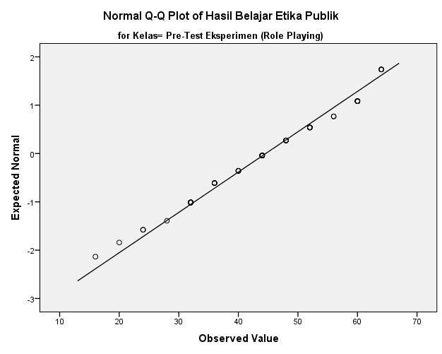

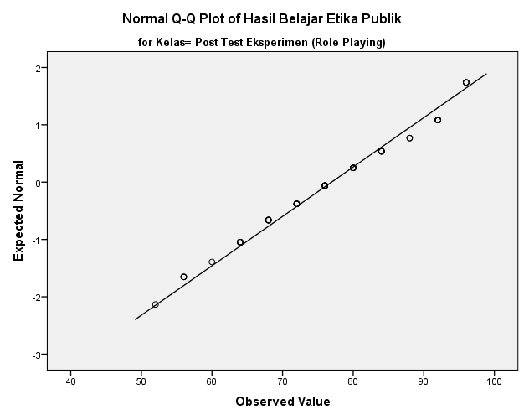

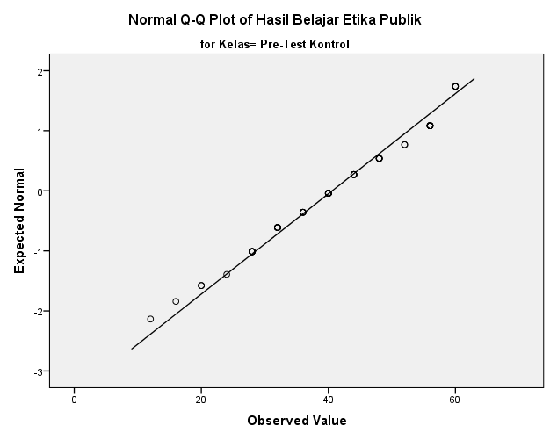

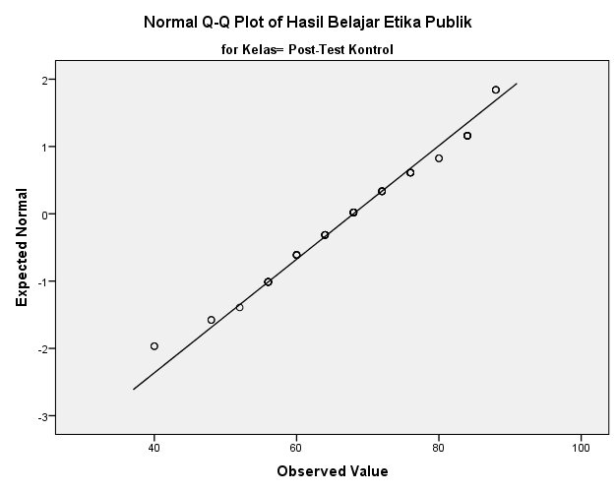

Detrended Normal Q-Q Plots

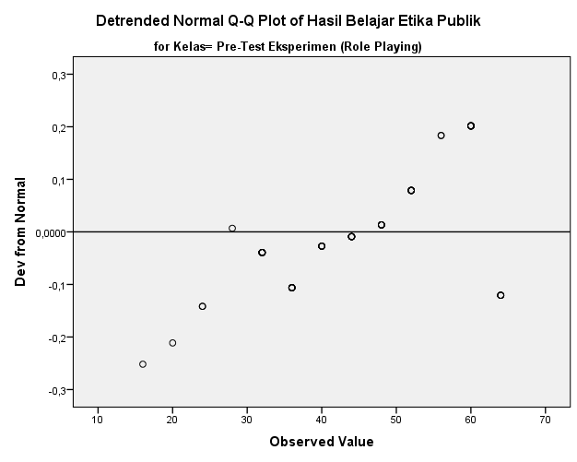

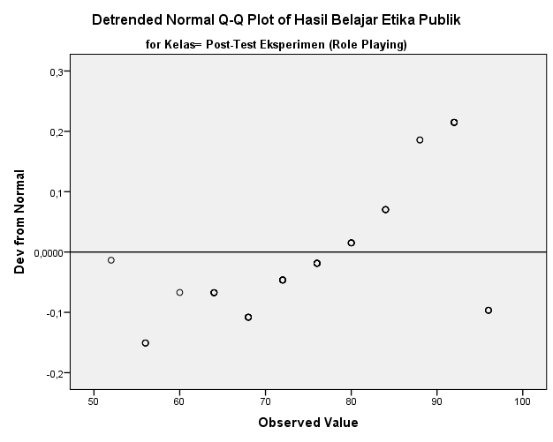

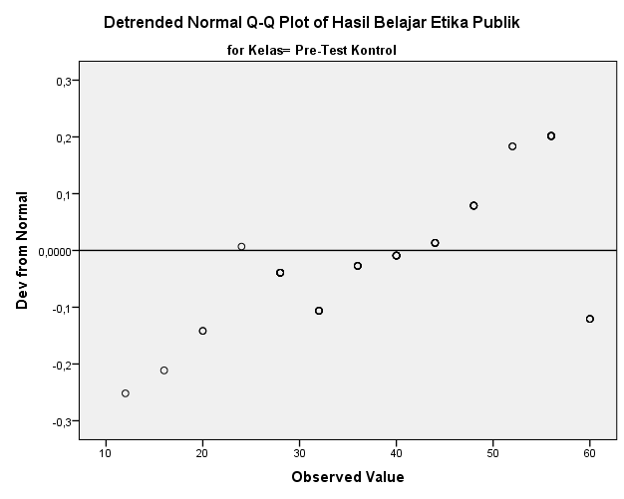

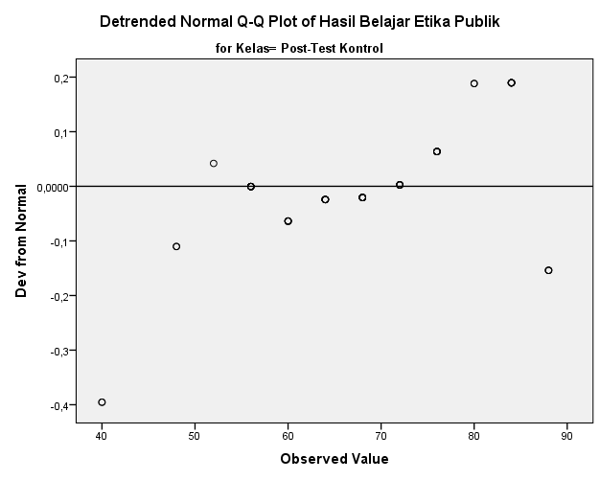

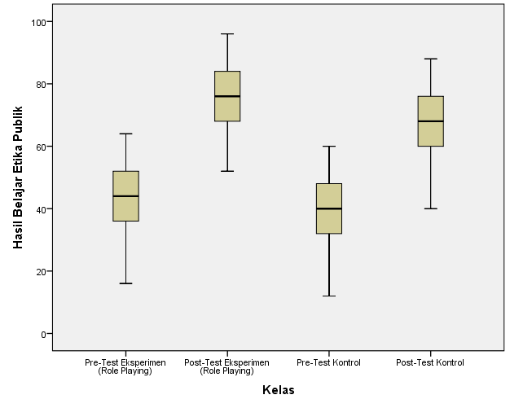

- Hasil Uji Paired Sample t-Test

Paired Samples Statistics
 |  | Mean | N | Std. Deviation | Std. Error Mean
Pair 1 | Pre Test Eksperimen | 44,60 | 60 | 12,052 | 1,556
Pair 1 | Post Test Eksperimen | 76,93 | 60 | 11,606 | 1,498
Pair 2 | Pre Test Kontrol | 40,60 | 60 | 11,985 | 1,547
Pair 2 | Post Test Kontrol | 68,00 | 60 | 11,852 | 1,530

Paired Samples Correlations
 |  | N | Correlation | Sig.
Pair 1 | Pre Test Eksperimen & Post Test Eksperimen | 60 | ,994 | ,000
Pair 2 | Pre Test Kontrol & Post Test Kontrol | 60 | ,989 | ,000

Paired Samples Test
 |  | Paired Differences |  |  |  |  | t | df | Sig. (2-tailed)
 |  | Mean | Std. Deviation | Std. Error Mean | 95% Confidence Interval of the Difference
 |  |  |  |  | Lower | Upper
Pair 1 | Pre Test Eksperimen - Post Test Eksperimen | -32,333 | 1,336 | ,172 | -32,678 | -31,988 | -187,443 | 59 | ,000
Pair 2 | Pre Test Kontrol - Post Test Kontrol | -27,400 | 1,777 | ,229 | -27,859 | -26,941 | -119,407 | 59 | ,000

- Hasil Uji Homogenitas

Test of Homogeneity of Variance
 |  |  | Levene Statistic |  | df1 |  | df2 | Sig.
Hasil Belajar Etika Publik | Based on Mean | ,006 |  | 1 |  | 118 |  | ,940
Hasil Belajar Etika Publik | Based on Median | ,000 |  | 1 |  | 118 |  | 1,000
Hasil Belajar Etika Publik | Based on Median and with adjusted df | ,000 |  | 1 |  | 117,681 |  | 1,000
Hasil Belajar Etika Publik | Based on trimmed mean | ,003 |  | 1 |  | 118 |  | ,960

- Hasil Uji Independent Sample t-Test

Group Statistics
 | Kelas | N | Mean | Std. Deviation | Std. Error Mean
Hasil Belajar Etika Publik | Post-Test Eksperimen | 60 | 76,93 | 11,606 | 1,498
Hasil Belajar Etika Publik | Post-Test Kontrol | 60 | 68,00 | 11,852 | 1,530

Independent Samples Test
 |  | Levene's Test for Equality of Variances |  | t-test for Equality of Means
 |  | F | Sig. | t | df | Sig. (2-tailed) | Mean Difference | Std. Error Difference | 95% Confidence Interval of the Difference
 |  |  |  |  |  |  |  |  | Lower | Upper
Hasil Belajar Etika Publik | Equal variances assumed | ,006 | ,940 | 4,171 | 118 | ,000 | 8,933 | 2,142 | 4,692 | 13,174
Hasil Belajar Etika Publik | Equal variances not assumed |  |  | 4,171 | 117,948 | ,000 | 8,933 | 2,142 | 4,692 | 13,174

- Hasil Uji N-Gain Score
Descriptives
 | Kelas |  |  | Statistic | Std. Error
NGain_persen | Eksperimen | Mean |  | 61,0888 | 1,72664
NGain_persen | Eksperimen | 95% Confidence Interval for Mean | Lower Bound | 57,6338
NGain_persen | Eksperimen | 95% Confidence Interval for Mean | Upper Bound | 64,5438
NGain_persen | Eksperimen | 5% Trimmed Mean |  | 60,5851
NGain_persen | Eksperimen | Median |  | 57,1429
NGain_persen | Eksperimen | Variance |  | 178,876
NGain_persen | Eksperimen | Std. Deviation |  | 13,37446
NGain_persen | Eksperimen | Minimum |  | 42,11
NGain_persen | Eksperimen | Maximum |  | 88,89
NGain_persen | Eksperimen | Range |  | 46,78
NGain_persen | Eksperimen | Interquartile Range |  | 16,67
NGain_persen | Eksperimen | Skewness |  | ,636 | ,309
NGain_persen | Eksperimen | Kurtosis |  | -,620 | ,608
NGain_persen | Kontrol | Mean |  | 47,9777 | 1,31135
NGain_persen | Kontrol | 95% Confidence Interval for Mean | Lower Bound | 45,3537
NGain_persen | Kontrol | 95% Confidence Interval for Mean | Upper Bound | 50,6017
NGain_persen | Kontrol | 5% Trimmed Mean |  | 47,6532
NGain_persen | Kontrol | Median |  | 46,6667
NGain_persen | Kontrol | Variance |  | 103,179
NGain_persen | Kontrol | Std. Deviation |  | 10,15771
NGain_persen | Kontrol | Minimum |  | 28,57
NGain_persen | Kontrol | Maximum |  | 70,00
NGain_persen | Kontrol | Range |  | 41,43
NGain_persen | Kontrol | Interquartile Range |  | 13,55
NGain_persen | Kontrol | Skewness |  | ,638 | ,309
NGain_persen | Kontrol | Kurtosis |  | -,397 | ,608

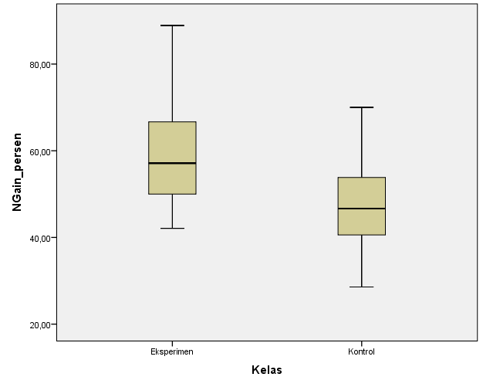

- Hasil Uji Regresi Linear Sederhana

Model Summary^{b}
Model | R | R Square | Adjusted R Square | Std. Error of the Estimate
1 | ,691ª | ,478 | ,469 | 8,461
a. Predictors: (Constant), Metode Role Playing
b. Dependent Variable: Hasil Belajar Etika Publik

ANOVAª
Model |  | Sum of Squares | df | Mean Square | F | Sig.
1 | Regression | 3795,554 | 1 | 3795,554 | 53,018 | ,000^{b}
1 | Residual | 4152,179 | 58 | 71,589
1 | Total | 7947,733 | 59
a. Dependent Variable: Hasil Belajar Etika Publik
b. Predictors: (Constant), Metode Role Playing

Coefficientsª
Model |  | Unstandardized Coefficients |  | Standardized Coefficients | t | Sig.
 |  | B | Std. Error | Beta | t | Sig.
1 | (Constant) | -2,671 | 10,987 |  | -,243 | ,809
1 | Metode Role Playing | 1,015 | ,139 | ,691 | 7,281 | ,000
a. Dependent Variable: Hasil Belajar Etika Publik

Residuals Statisticsª
 | Minimum | Maximum | Mean | Std. Deviation | N
Predicted Value | 58,22 | 92,73 | 76,93 | 8,021 | 60
Std. Predicted Value | -2,333 | 1,970 | ,000 | 1,000 | 60
Standard Error of Predicted Value | 1,094 | 2,792 | 1,487 | ,423 | 60
Adjusted Predicted Value | 57,03 | 92,44 | 76,90 | 8,079 | 60
Residual | -22,464 | 11,447 | ,000 | 8,389 | 60
Std. Residual | -2,655 | 1,353 | ,000 | ,991 | 60
Stud. Residual | -2,680 | 1,368 | ,002 | 1,005 | 60
Deleted Residual | -22,882 | 11,766 | ,033 | 8,625 | 60
Stud. Deleted Residual | -2,838 | 1,379 | -,004 | 1,021 | 60
Mahal. Distance | ,003 | 5,441 | ,983 | 1,252 | 60
Cook's Distance | ,000 | ,092 | ,014 | ,017 | 60
Centered Leverage Value | ,000 | ,092 | ,017 | ,021 | 60
a. Dependent Variable: Hasil Belajar Etika Publik

Charts
