OUTPUT

DATE: 6/23/2020
TIME: 11:52

L I S R E L 8.80

BY

Karl G. Jöreskog & Dag Sörbom

This program is published exclusively by
Scientific Software International, Inc.
7383 N. Lincoln Avenue, Suite 100
Lincolnwood, IL 60712, U.S.A.
Phone: (800)247-6113, (847)675-0720, Fax: (847)675-2140
Copyright by Scientific Software International, Inc., 1981-2006
Use of this program is subject to the terms specified in the
Universal Copyright Convention.
Website: www.ssicentral.com

The following lines were read from file C:\Users\angga\Documents\DATA PENELITIAN JURNAL\LISREL S & W\SW.SPJ:

Raw Data from file 'C:\Users\angga\Documents\DATA PENELITIAN JURNAL\LISREL S & W\SW.psf'
Sample Size = 375
Observed variables: X Y1 Y2
Correlation matrix
1.000
0.372 1.000
0.473 0.716 1.000
Relationships
Y2 = Y1
Y1 = X
Y2 = X
Options: SS EF
Path Diagram
End of Problem

Sample Size = 375

Correlation Matrix

Y1 Y2 X
-------- -------- --------
Y1 1.00
Y2 0.72 1.00
X 0.37 0.47 1.00

Number of Iterations = 0

LISREL Estimates (Maximum Likelihood)

Structural Equations

Y1 = 0.37*X, Errorvar.= 0.86 , R² = 0.14
(0.048) (0.063)
7.74 13.66

Y2 = 0.63*Y1 + 0.24*X, Errorvar.= 0.44 , R² = 0.56
(0.037) (0.037) (0.032)
16.98 6.50 13.66

Reduced Form Equations

Y1 = 0.37*X, Errorvar.= 0.86, R² = 0.14
(0.048)
7.74

Y2 = 0.47*X, Errorvar.= 0.78, R² = 0.22
(0.046)
10.37

Correlation Matrix of Independent Variables

X
--------
1.00
(0.07)
13.66

Covariance Matrix of Latent Variables

Y1 Y2 X
-------- -------- --------
Y1 1.00
Y2 0.72 1.00
X 0.37 0.47 1.00

Goodness of Fit Statistics

Degrees of Freedom = 0
Minimum Fit Function Chi-Square = 0.0 (P = 1.00)
Normal Theory Weighted Least Squares Chi-Square = 0.0 (P = 1.00)

The Model is Saturated, the Fit is Perfect !

Standardized Solution

BETA

Y1 Y2
-------- --------
Y1 - - - -
Y2 0.63 - -

GAMMA

X
--------
Y1 0.37
Y2 0.24

Correlation Matrix of Y and X

Y1 Y2 X
-------- -------- --------
Y1 1.00
Y2 0.72 1.00
X 0.37 0.47 1.00

PSI
Note: This matrix is diagonal.

Y1 Y2
-------- --------
0.86 0.44

Regression Matrix Y on X (Standardized)

X
--------
Y1 0.37
Y2 0.47

Total and Indirect Effects

Total Effects of X on Y

X
--------
Y1 0.37
(0.05)
7.74
Y2 0.47
(0.05)
10.37

Indirect Effects of X on Y

X
--------
Y1 - -
Y2 0.23
(0.03)
7.04

Total Effects of Y on Y

Y1 Y2
-------- --------
Y1 - - - -
Y2 0.63 - -
(0.04)
16.98

Largest Eigenvalue of B*B' (Stability Index) is 0.393

Standardized Total and Indirect Effects

Standardized Total Effects of X on Y

X
--------
Y1 0.37
Y2 0.47

Standardized Indirect Effects of X on Y

X
--------
Y1 - -
Y2 0.23

Standardized Total Effects of Y on Y

Y1 Y2
-------- --------
Y1 - - - -
Y2 0.63 - -

Time used: 0.016 Seconds

PATH DIAGRAM

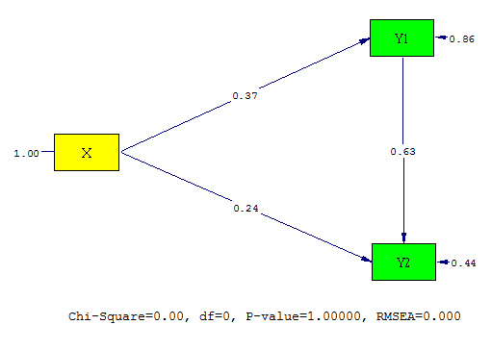

Koefisien Jalur

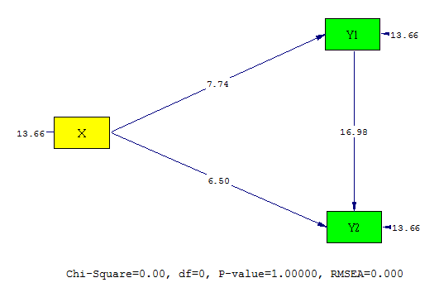

T-Hitung

