LAMPIRAN

Lampiran 1. Dataset kambing dan domba
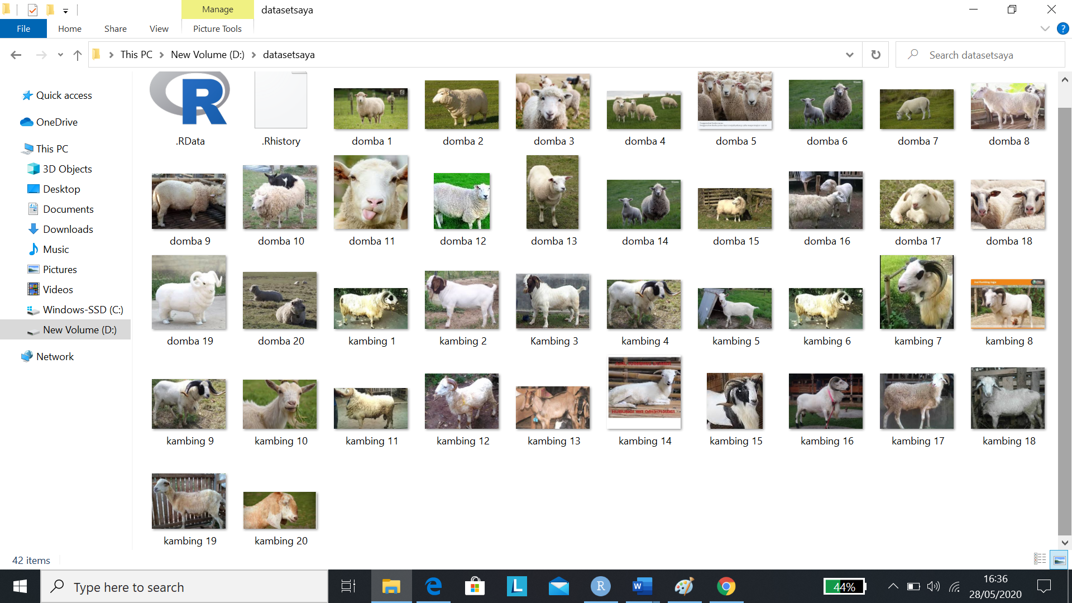Lampiran 2. Kode program CNN untuk klasifikasi kambing dan domba
library (devtools)
library(keras)
library (BiocManager)
library(EBImage)
library(reticulate)
library(tensorflow)

#input data
setwd('D:/datasetsaya')
# Read Images
images <- list.files()
images
summary(images)
list_of_images = lapply(images,readImage)
list_of_images
display(list_of_images[[5]])
#createtest
test <- list_of_images [c(17:20,37:40)]
test
display(test[[1]])
par(mfrow=c(2,4))
for (i in 1:8) plot(test[[i]])
#createtrain
train<- list_of_images [c(1:16,21:36)]
train
display (train[[1]])
par(mfrow=c(4,8))
for (i in 1:32) plot(train[[i]])
# Resize & combine
for (i in 1:32) {train[[i]] <- resize(train[[i]], 32, 32)}
for (i in 1:8) {test[[i]] <- resize(test[[i]], 32, 32)}
train <- combine(train)
str(train)
x <- tile(train, 8)
display(x, title='Pictures')
test <- combine(test)
y <- tile(test, 4)
display(y, title = 'Pics')
# Reorder dimension
dim(test)
dim(train)
train <- aperm(train, c(4,1,2,3))
test <- aperm(test, c(4,1,2,3))
str(train)
str(test)
# Response
trainy <- c(rep(0,16),rep(1,16))
testy <- c(rep(0,4),rep(1,4))
#install.packages
#devtools::install_github('rstudio/keras')
library(reticulate)
# One hot encoding
trainLabels <- to_categorical(trainy)
testLabels <- to_categorical(testy)
trainLabels
testLabels
# Model
model <- keras_model_sequential()
model %>%
layer_conv_2d(filters = 32,
kernel_size = c(3,3),
activation = 'relu',
input_shape = c(32, 32, 3)) %>%
layer_conv_2d(filters = 32,
kernel_size = c(3,3),
activation = 'relu') %>%
layer_max_pooling_2d(pool_size = c(2,2)) %>%
layer_dropout(rate = 0.01) %>%
layer_conv_2d(filters = 64,
kernel_size = c(3,3),
activation = 'relu') %>%
layer_conv_2d(filters = 64,
kernel_size = c(3,3),
activation = 'relu') %>%
layer_max_pooling_2d(pool_size = c(2,2)) %>%
layer_dropout(rate = 0.01) %>%
layer_flatten() %>%
layer_dense(units = 256, activation = 'relu') %>%
layer_dropout(rate=0.01) %>%
layer_dense(units = 2, activation = 'softmax') %>%
compile(loss = 'categorical_crossentropy',
optimizer = optimizer_sgd(lr = 0.01,
decay = 1e-6,
momentum = 0.9,
nesterov = T),
metrics = c('accuracy'))
summary(model)
# Fit model
history <- model %>%
fit(train,
trainLabels,
epochs =70,
batch_size = 32,
validation_split = 0.2,
validation_data = list(test, testLabels)
)
plot(history)
model %>% evaluate(train, trainLabels)
pred <- model %>% predict_classes(train)
table(Predicted = pred, Actual = trainy)
pred
trainy
model %>% evaluate(test, testLabels)
pred <- model %>% predict_classes(test)
table(Predicted = pred, Actual = testy)
pred
testy

Lampiran 3. Contoh hasil CNN dengan epoch = 10
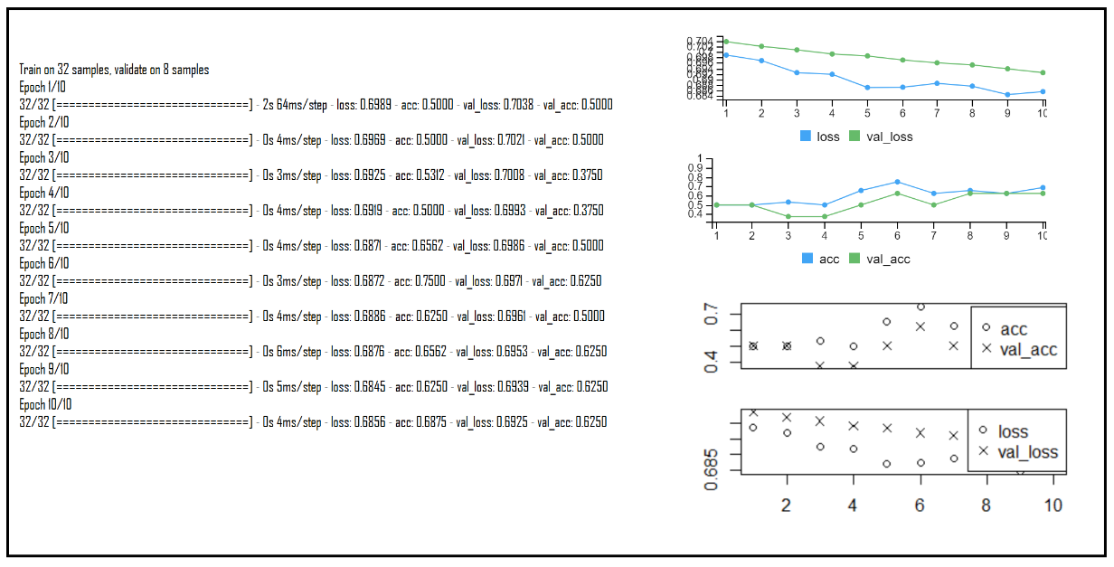
Lampiran 4. Contoh hasil CNN dengan epoch 70
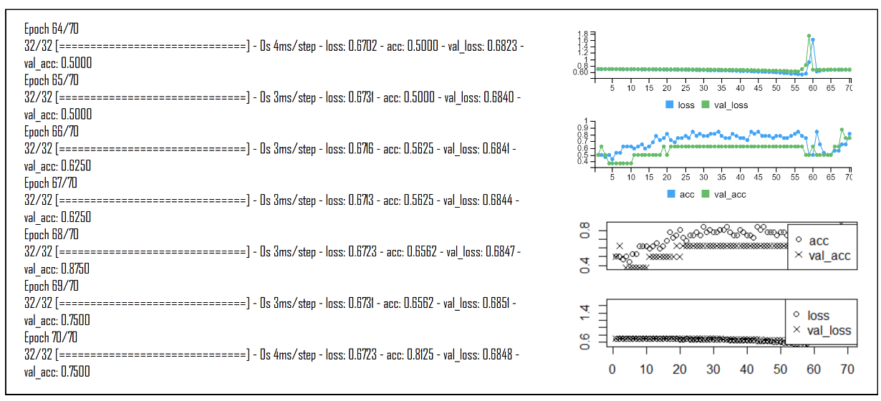
Lampiran 5. Contoh hasil CNN dengan epoch 100
